Republic of Panama

Ministry of Education

Centro Educativo Media de Progreso

Group: XI°F

Subject: English

Teacher: John Ríos

Members: Luis Castrellón, Gabriel Cerrud

Topic: Pollution

School Year: 2025

# Executive Summary

This expanded report examines pollution in Panama in depth. It covers air, water, soil and solid waste, and noise pollution, including their sources, health and ecological impacts, and feasible solutions for households, schools, businesses, and local authorities. We also present an action plan with roles and a practical checklist to help communities apply the recommendations immediately.

Key points: Urban areas face recurring air quality and noise issues linked to traffic and construction; rivers and coastal zones are stressed by untreated wastewater and litter; recycling rates remain low due to poor separation; and sustained education, monitoring, and infrastructure investments are needed to reverse these trends and protect public health.

# Introduction

Pollution is the introduction of harmful substances or energy into the environment that cause adverse change. In Panama, pollution is visible in the air people breathe, the rivers and coasts that sustain biodiversity and tourism, the soil that supports agriculture, and the soundscapes of fast‑growing cities. Because Panama hosts rich ecosystems and strategic infrastructure like the Panama Canal, environmental quality is tightly connected to economic development and social well‑being.

This document has five goals: (1) define the concept of pollution and key terms; (2) describe Panama’s main pollution sources; (3) explain their impacts on health, ecosystems, and the economy; (4) present solutions at different scales; and (5) provide a checklist and timeline to support implementation in schools and neighborhoods.

# Key Concepts and Vocabulary

• Pollutant: Any substance or form of energy that causes harm to living organisms or ecosystems.

• Exposure: The contact of a person or ecosystem with a pollutant over time.

• PM2.5: Fine particles 2.5 micrometers or smaller; can penetrate deep into the lungs and bloodstream.

• Eutrophication: Nutrient enrichment of water bodies causing algal blooms and low oxygen.

• Leachate: Liquid that drains from waste, potentially contaminating soil and groundwater.

• Waste segregation: Separation of organic, recyclable, and hazardous waste to enable proper treatment.

• Environmental monitoring: Systematic measurement of indicators (air particles, water quality) to inform decisions.

# Air Pollution in Panama

Main sources include: road traffic (cars, buses, trucks), diesel engines in logistics and port operations, open burning of waste, some industrial processes, and dust from construction. Peak congestion periods worsen conditions along major corridors in large cities.

Health impacts: exposure to fine particles and ozone can trigger or aggravate asthma and bronchitis, increase the risk of heart disease, and reduce overall lung function. Children, older adults, and people with respiratory illnesses are the most vulnerable.

Practical solutions: improve public transportation coverage and reliability; encourage carpooling and non‑motorized mobility; enforce vehicle maintenance and emissions controls; use dust suppression at construction sites; and increase green spaces that buffer neighborhoods.

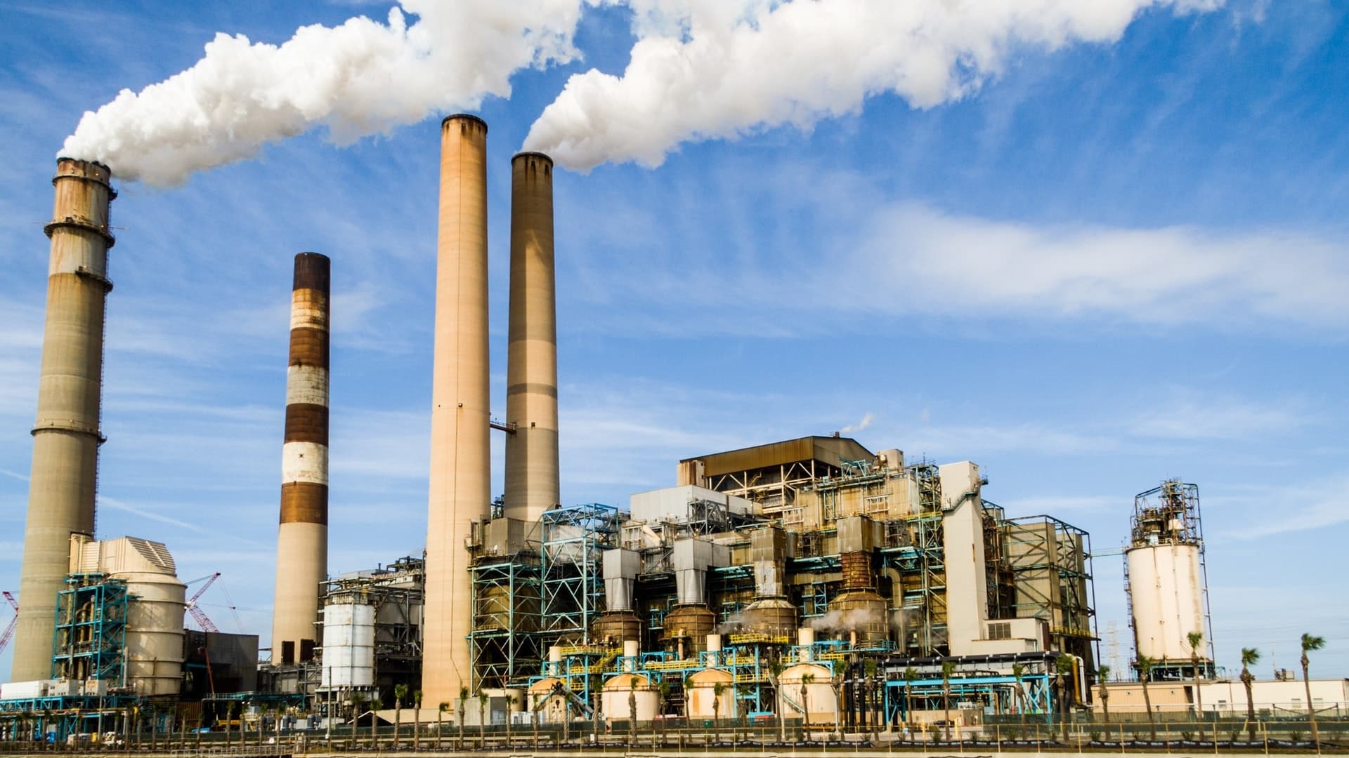

## Case Study: Urban Corridor

Along a busy urban corridor, thousands of vehicles pass daily, producing nitrogen oxides and particulate matter. Installing synchronized traffic lights, improving bus frequency, and creating a protected cycling lane can significantly reduce idle times and emissions. Schools nearby can monitor air using low‑cost sensors, compare results before and after changes, and present findings to the community and local council.

# Water Pollution in Panama

Sources: untreated or partially treated wastewater from households and businesses; stormwater carrying trash, oils, and sediments; agricultural runoff rich in nutrients; and accidental spills from transport or industrial activities. River mouths and bays are especially sensitive because contaminants accumulate in slower‑moving waters.

Impacts: poor water quality affects fisheries, tourism, and recreation. Algal blooms reduce oxygen and can kill fish; floating litter harms wildlife and creates negative visual impressions for visitors; and pathogens can spread disease among nearby residents.

Solutions: expand and properly operate wastewater treatment; protect riverbanks with vegetation; control stormwater with filtration and retention areas; organize clean‑ups before trash reaches waterways; and use simple school projects—like Secchi disk measurements—to observe improvements over time.

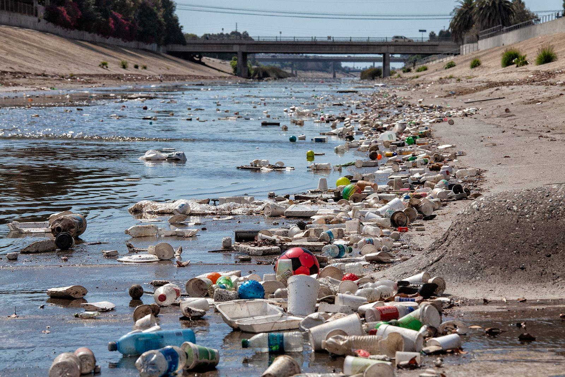

# Soil Pollution and Solid Waste

Soil contamination results from spills, improper disposal of oils and chemicals, excessive pesticide use, and leachate from unmanaged dumps. In urban areas, irregular collection and scarce recycling lead to overflowing bins and illegal dumping, which then washes into streams during heavy rain.

Impacts include reduced soil fertility, risks to food safety, and increased greenhouse gas emissions from decomposing organic waste. Open dumping also attracts insects and rodents, which can spread disease.

Solutions: implement source separation at homes and schools (organic, recyclables, non‑recyclables, hazardous); promote composting of food scraps and yard trimmings; set up drop‑off points for electronics and batteries; support local recycling markets for paper, cardboard, glass, certain plastics, and metals.

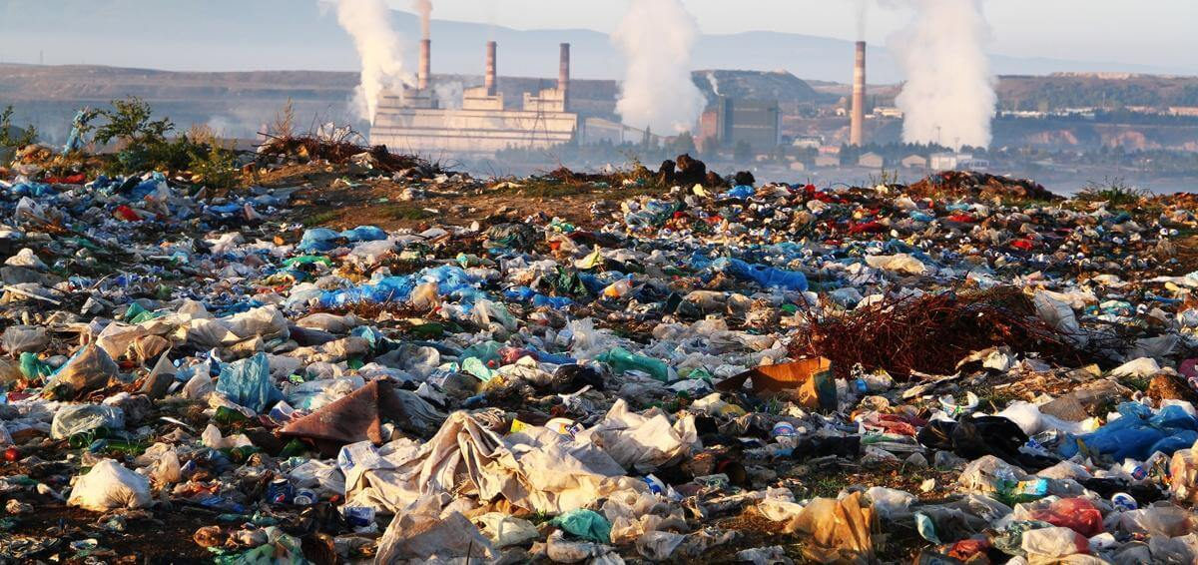

# Noise Pollution

Common sources are dense traffic, heavy trucks, aircraft near airports, construction machinery, and loud speakers in commercial zones. Though often overlooked, chronic noise exposure contributes to stress, sleep disturbance, and reduced academic performance in students.

Mitigation: enforce quiet hours and noise limits; maintain vehicle exhaust systems; use barriers or vegetative buffers near busy roads; and plan construction schedules to minimize disturbance to nearby schools and hospitals.

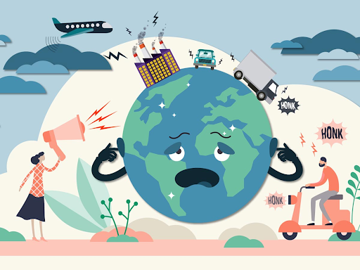

# Social and Economic Impacts

Public health costs rise when air and water quality decline, as more people seek treatment for respiratory and gastrointestinal illnesses. Environmental degradation also affects tourism and fisheries, sectors that depend on clean beaches, rivers, and landscapes.

Households experience hidden costs: time lost due to congestion-related pollution, fewer safe outdoor activities for children, and lower property values in areas with poor environmental quality. Investing in prevention—wastewater infrastructure, recycling programs, and green transport—can be more cost‑effective than paying for cleanup later.

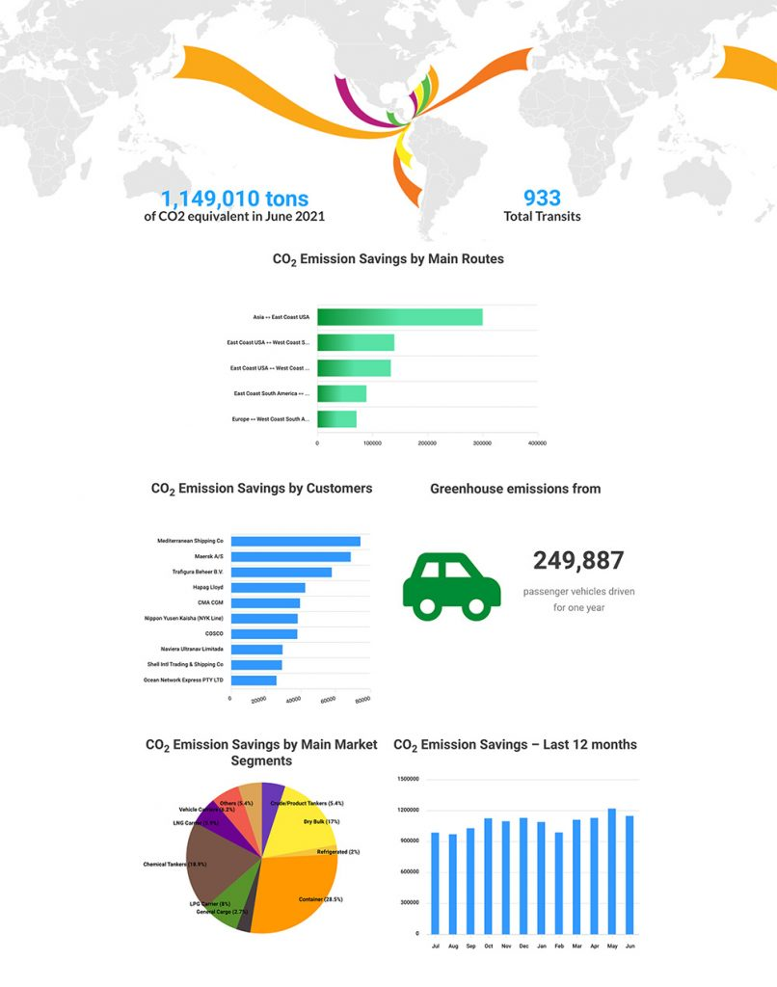

# Current Actions and Community Projects

Across the country, schools and local organizations organize beach and river clean‑ups, tree‑planting days, and educational workshops about waste separation. Municipalities are testing selective collection and businesses are adopting cleaner technologies and reducing single‑use plastics.

Suggested school project: establish a “Zero‑Litter Zone” around the campus with weekly monitoring, clear signage, separate bins, and a student volunteer rota. Track progress by weighing recyclables and organic waste diverted each month and presenting results to the wider community.

# Action Plan and Roles

• Government: improve public transport; expand wastewater treatment; enforce environmental standards; publish monitoring data in accessible formats.

• Private Sector: adopt cleaner production; report environmental performance; support recycling value chains; reduce single‑use plastics in operations.

• Communities & NGOs: organize clean‑ups; monitor local rivers; train volunteers; partner with schools to deliver environmental education.

• Households: separate waste; reduce, reuse, and recycle; avoid burning trash; maintain vehicles; report illegal dumping.

• Schools: integrate environmental topics across subjects; create eco‑clubs; conduct simple air and water observations with low‑cost kits.

# Recommendations

1) Strengthen waste separation and recycling through clear labeling, convenient collection points, and public awareness campaigns.

2) Expand and maintain wastewater treatment plants; protect riverbanks with green buffers and prevent direct discharges.

3) Improve urban mobility and lower emissions with efficient buses, safe sidewalks, and cycling routes.

4) Standardize noise control and promote quiet hours, especially near schools, hospitals, and residential areas.

5) Publish air and water quality data regularly to build trust and guide community action.

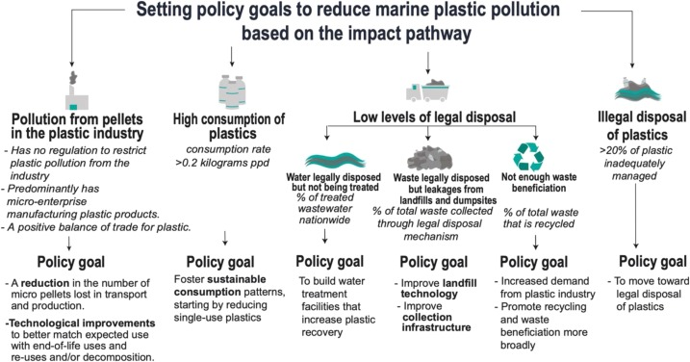

# Conclusions

Conclusion 1:  
Pollution in Panama affects air, water, soil, and the acoustic environment, with direct consequences for public health and biodiversity. Because these issues are interconnected, solutions must combine infrastructure, regulation, and changes in daily behavior.

Conclusion 2:  
Progress is achievable: by separating waste, preventing discharges, improving transport, protecting riverbanks, and educating citizens, communities can significantly improve environmental quality and quality of life. Collaboration among government, schools, households, and businesses is essential.

# References

<https://ritellopanama.com/contaminacion-del-aire-en-panama>

<https://www.webscolar.com/los-problemas-de-contaminacion-del-agua-en-panama>

<https://www.anywhere.com/panama/travel-guide/environmental-issues>

<https://www.tavsapanama.com/contaminacion-del-agua-en-panama>

<https://elpais.com/america-futura/2024-03-30/cerro-patacon-una-nube-de-humo-toxico-y-un-desastre-ambiental-en-pausa-en-panama.html>

annexes

